Trường Đại học Công Nghiệp Dệt May Hà Nội  KHOA TIN HỌC NGOẠI NGỮ  Đề thi gồm 4 phần  Sinh viên không được sử dụng tài liệu | MINH HỌA ĐỀ THI ĐẦU VÀO TIẾNG ANH  Kỹ năng: Nghe  Thời gian: 45 phút
Part 1_Picture description:
Directions: For each questions in this part, you will hear four statements about a picture in your test. When you hear the statements, you must select the one statement that best describes what you see in the picture. Then find the number of the question on your answer sheet and mark your answer. The statement will not be printed in your test and will be spoken only one time.
Example: Statement (B), “ They are standing near the table” is the best description of the picture, so you should select answer (B) and mark it on your answer sheet.
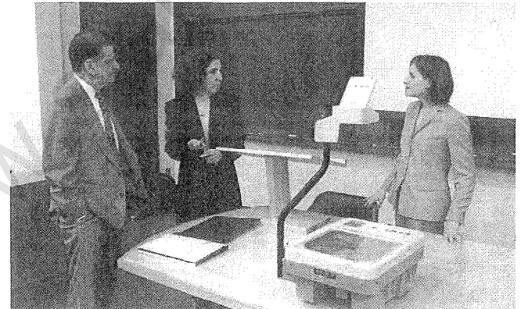

No | Pictures | No | Pictures
1.  A  B  C  D | 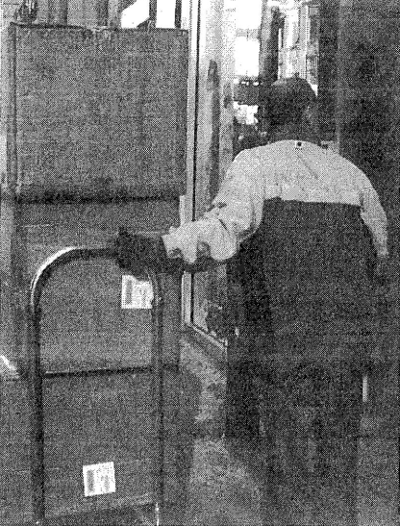 | 2.  A  B  C  D | 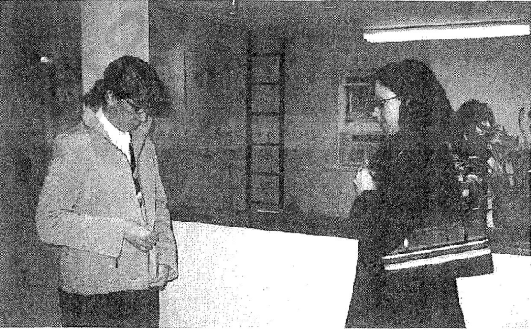
3  A  B  C  D | 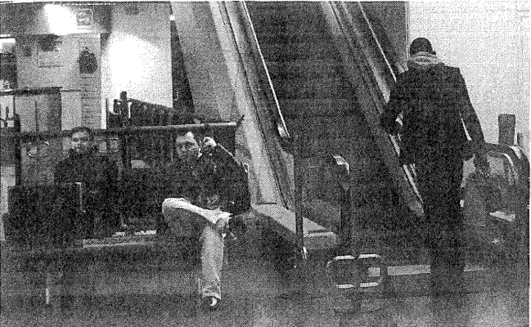 | 4  A  B  C  D
5  A  B  C  D | 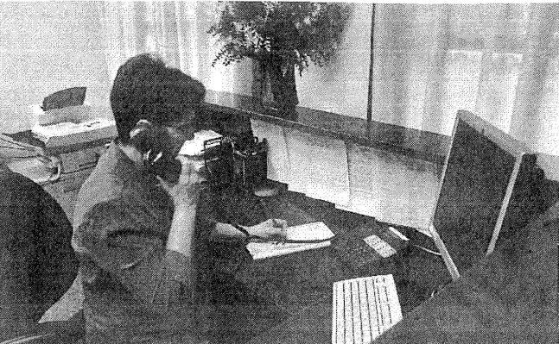 | 6.  A  B  C  D | 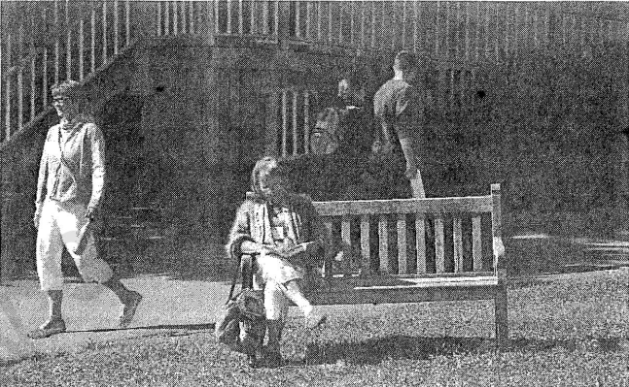
7.  A  B  C  D | 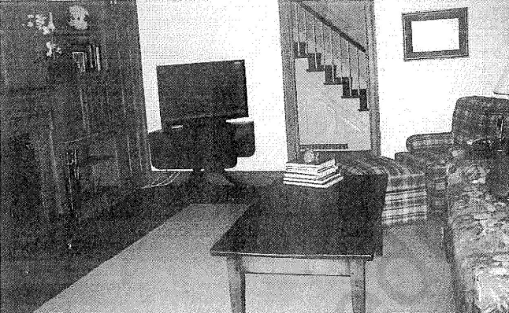 | 8.  A  B  C  D | 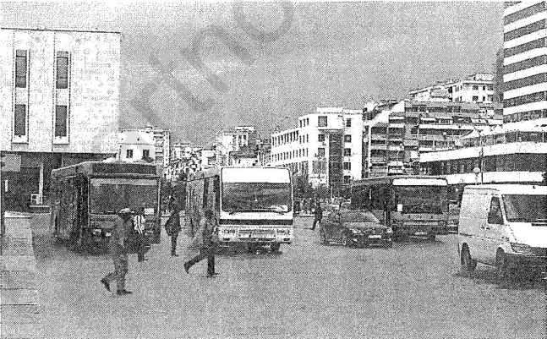
9.  A  B  C  D | 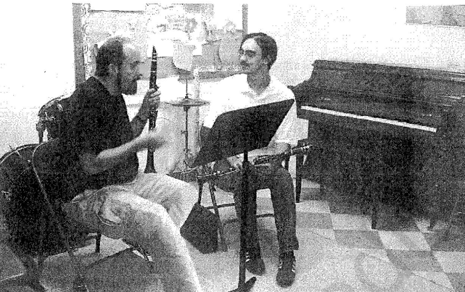 | 10.  A  B  C  D | 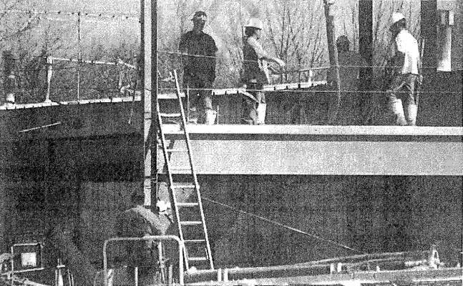
PART 2_Questions and responses
Directions: You will hear a question or statement and three responses spoken in English. They will be spoken only one time and will not be printed in your test book. Select the best response to the question or statement and mark the letter A, B, or C on your answer sheet.
Example: You will hear: Where is the meeting room?
You will also hear: A- To meet the new director.
B- It’s the first room on the right.
C- Yes, at 2 o’clock.
11. A B C | 21. A B C | 31. A B C
12. A B C | 22. A B C | 32. A B C
13. A B C | 23. A B C | 33. A B C
14. A B C | 24. A B C | 34. A B C
15 A B C | 25. A B C | 35. A B C
16. A B C | 26. A B C | 36. A B C
17. A B C | 27. A B C | 37. A B C
18. A B C | 28. A B C | 38. A B C
19. A B C | 29. A B C | 39. A B C
20. A B C | 30. A B C | 40. A B C

Part 3_Short conversation
Directions: You will hear some conversation between two people. You will be asked to answer three questions about what the speakers say in each conversation. Select the best response to each question and mark the letter A, B, C or D on your answer sheet. The conversation will be spoken only one time and will not be printed in your test book.
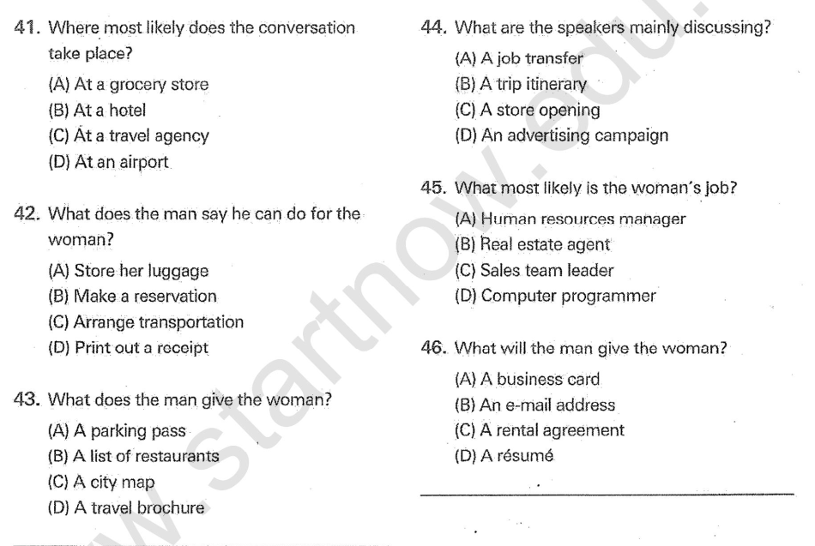
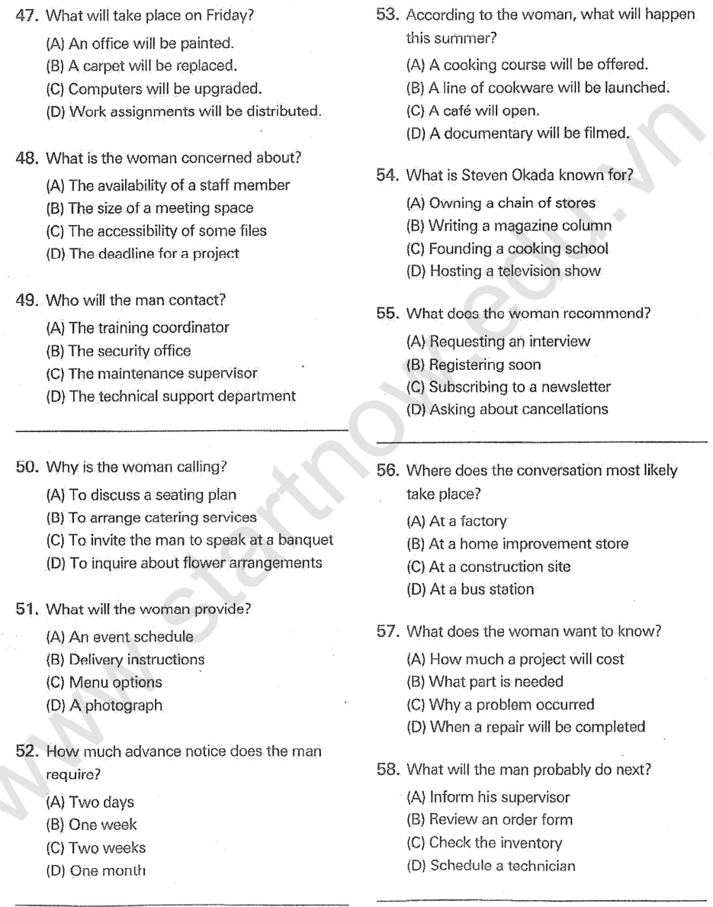
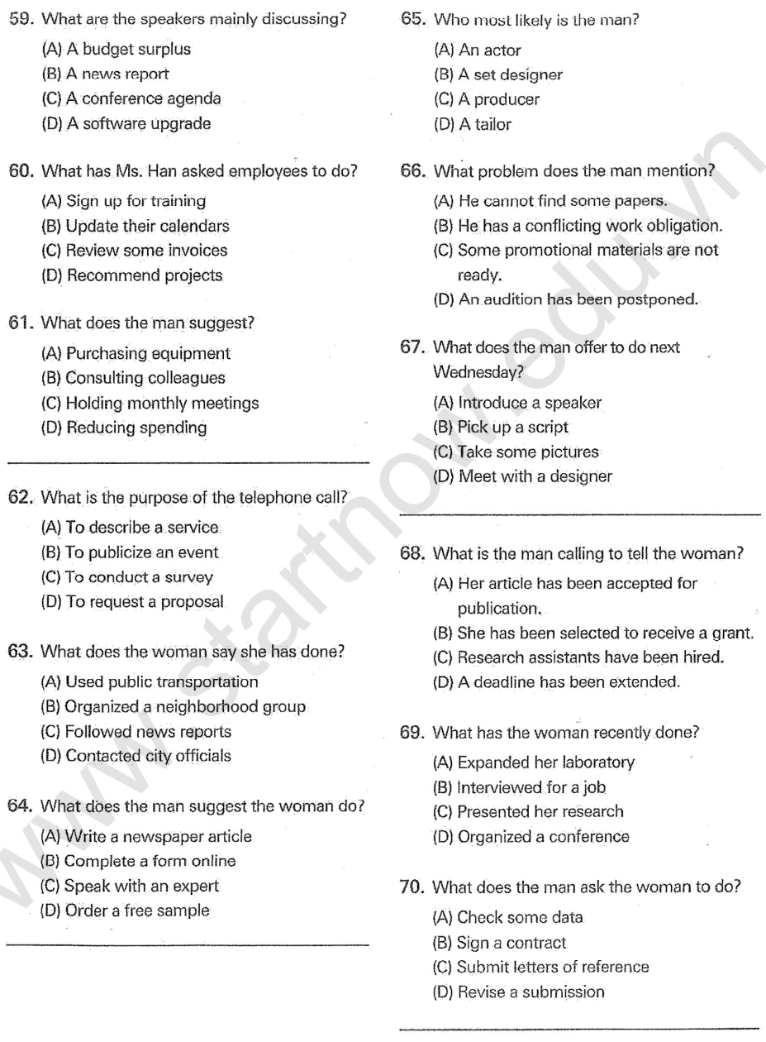

Part 4: You will hear some short talks given by a single speaker. You will be asked to answer three questions about what the speaker says in each short talk. Select the best response to each question and mark the letter A, B, C or D on your answer sheet. The talks will be spoken one time and will not be printed in your test.
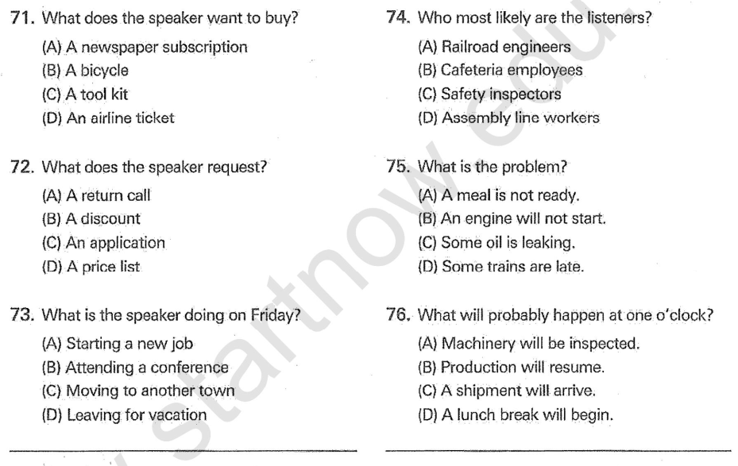
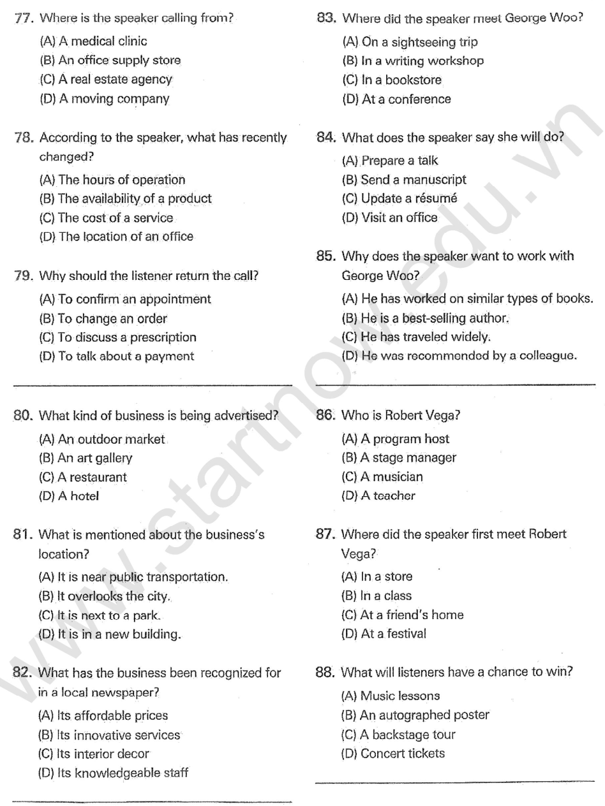
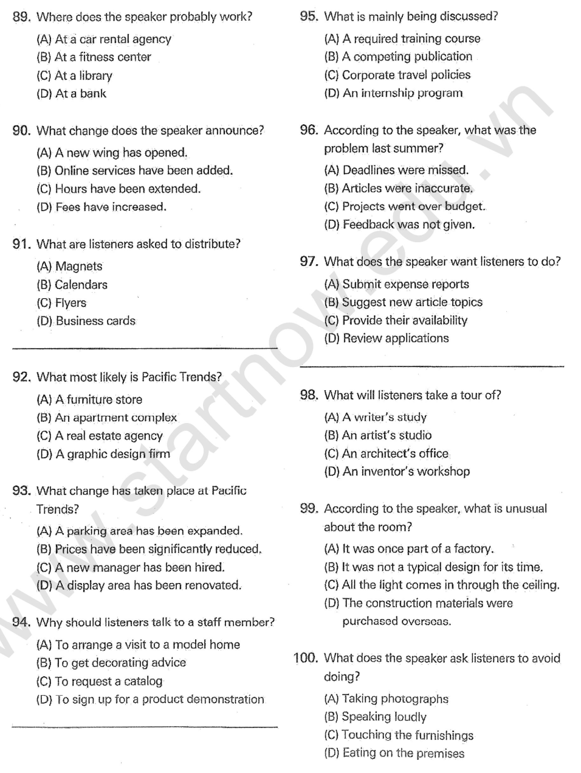
The end of listening test 04

