Trường Đại học Công Nghiệp Dệt May Hà Nội  KHOA TIN HỌC – NGOẠI NGỮ  Đề thi gồm 3 phần  Sinh viên không được sử dụng tài liệu | ĐỀ THI MINH HỌA KIỂM TRA ĐẦU VÀO  TIẾNG ANH  Kỹ năng: Viết  Thời gian: 45 phút
Part 1. Write a sentence based on a picture (40 pts)
Direction: In this part of the test, you will write ONE sentence that is based on a picture. With each picture, you will be given TWO words or phrases that you must use in your sentence. You can change the forms of the words and you can use the words in any order. Your sentences will be scored on:
+ the appropriate use of grammar
+ the relevance of the sentence to the picture

Example | Sample response
 | The woman is writing in a notebook
write/ notebook

Shopping/ supermarket
Lunch/ restaurant
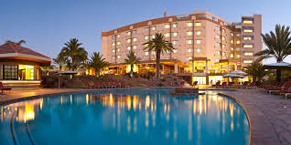
Swimming pool/ hotel
Like/ salad
Girls/ race

Part 2: Writing an email (60 pts)
Derection: In this part of the test, you will show how well you can write an email. Your response will be scored on:
- The quality anf variety of your sentences
- Vocabulary
- Organisation
You have 15 minutes to read and write the email.
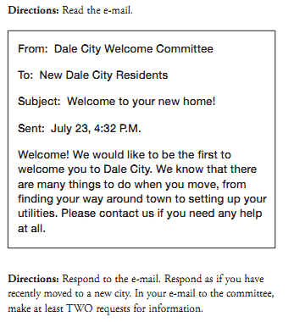

…………………………………………………………………………………………………
…………………………………………………………………………………………………
…………………………………………………………………………………………………
…………………………………………………………………………………………………
…………………………………………………………………………………………………
…………………………………………………………………………………………………
…………………………………………………………………………………………………
…………………………………………………………………………………………………
…………………………………………………………………………………………………
…………………………………………………………………………………………………
…………………………………………………………………………………………………
Part 3: Write an opinion essay (100 points)
Directions: You will write an essay in response to questions that ask you to explain and support your opinion. Your essay will contain a minimum of 150 words.
Your response will be scored on:
- Whether our opinion is supported with reasons and/ or examples,
- Grammar
- Vocabulary, and
- Organisation.
You will have 20 minutes to plan and write your essay
“Nowadays parents put too much pressure on their children to succeed. What is the reason for doing this? Is this negative or positive development?”
…………………………………………………………………………………………………
…………………………………………………………………………………………………
…………………………………………………………………………………………………
…………………………………………………………………………………………………
…………………………………………………………………………………………………
…………………………………………………………………………………………………
…………………………………………………………………………………………………
…………………………………………………………………………………………………
…………………………………………………………………………………………………
…………………………………………………………………………………………………
…………………………………………………………………………………………………
…………………………………………………………………………………………………
…………………………………………………………………………………………………
…………………………………………………………………………………………………
…………………………………………………………………………………………………
…………………………………………………………………………………………………
…………………………………………………………………………………………………
…………………………………………………………………………………………………
…………………………………………………………………………………………………

Tổ trưởng  (Ký và ghi rõ họ tên)  Lê Nguyên Hương | Giáo viên ra đề  (Ký và ghi rõ họ tên)  Phạm Kim Anh

