Trường Đại học Công Nghiệp Dệt May Hà Nội  KHOA TIN HỌC – NGOẠI NGỮ  Đề thi gồm 3 phần  Sinh viên không được sử dụng tài liệu  Đề số: 1 | ĐỀ KIỂM TRA ĐẦU VÀO  Số phách:  Môn: Tiếng Anh  Đối tượng: Đại học – K5  Kỹ năng: Viết  Thời gian: 30 phút
Part 1. Write a sentence based on a picture (100 pts)
Direction: In this part of the test, you will write ONE paragraph within 15-20 sentences that are based on a picture. Your sentences will be scored on:
+ the appropriate use of grammar
+ the relevance of the sentence to the picture
+ the variety of vocabulary
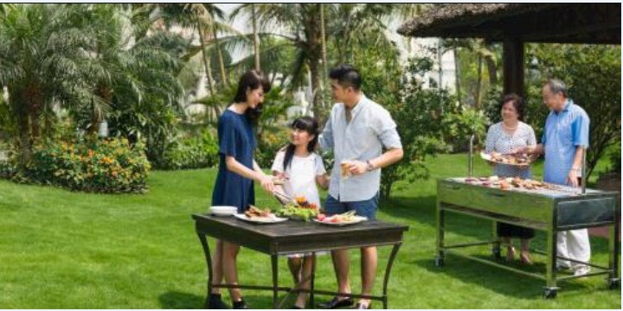
…………………………………………………………………………………………………
…………………………………………………………………………………………………
…………………………………………………………………………………………………
…………………………………………………………………………………………………
…………………………………………………………………………………………………
…………………………………………………………………………………………………
…………………………………………………………………………………………………
…………………………………………………………………………………………………
…………………………………………………………………………………………………
…………………………………………………………………………………………………

Part 2: Write an opinion essay (100 points)
Directions: You will write an essay in response to questions that ask you to explain and support your opinion. Your essay will contain a minimum of 150 words.
Your response will be scored on:
- Whether our opinion is supported with reasons and/ or examples,
- Grammar
- Vocabulary, and
- Organisation.
You will have 20 minutes to plan and write your essay
“Nowadays parents put too much pressure on their children to succeed. What is the reason for doing this? Is this negative or positive development?”
…………………………………………………………………………………………………
…………………………………………………………………………………………………
…………………………………………………………………………………………………
…………………………………………………………………………………………………
…………………………………………………………………………………………………
…………………………………………………………………………………………………
…………………………………………………………………………………………………
…………………………………………………………………………………………………
…………………………………………………………………………………………………
…………………………………………………………………………………………………
…………………………………………………………………………………………………
…………………………………………………………………………………………………
…………………………………………………………………………………………………
…………………………………………………………………………………………………
…………………………………………………………………………………………………
…………………………………………………………………………………………………
…………………………………………………………………………………………………
…………………………………………………………………………………………………

