Trường Đại Học Công Nghiệp Dệt May Hà Nội  KHOA TIN HỌC – NGOẠI NGỮ  Đề thi gồm 4 phần  Sinh viên không được sử dụng tài liệu  Đề số: 01 | ĐỀ KIỂM TRA ĐẦU VÀO ĐẠI HỌC  (Đối tượng: ĐH- K8)  Kỹ năng: Nghe (New Format)  Thời gian: 45 phút

LISTENING TEST
In the listening test, you will be asked to demonstrate how well you understand spoken English. The entire listening test will last approximately 45 minutes. There are four parts and directions are given for each part. You must mark your answers on the separate answer sheet. Do not write your answers in your test book.
PART 1
Directions: For each question in this part, you will hear four statements about a picture in your test book. When you hear the statements, you must select the one statement that best describes what you see in the picture. Then find the number of the question on your answer sheet and mark your answer. The statements will not be printed in your test book and will be spoken only one time.

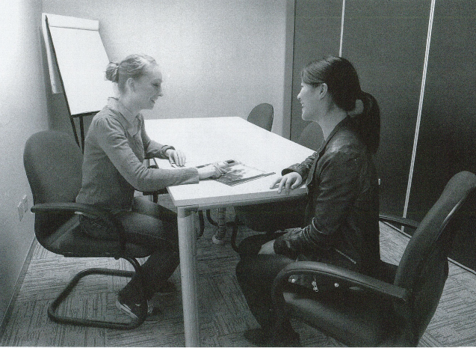

Statement C, “they are sitting at a table,” is the best description of the picture, so you should select answer C and mark it on your answer sheet.

b
Listen and choose the statement that best describes the picture.
No. | Pictures | No. | Pictures
1.  A  B  C  D | 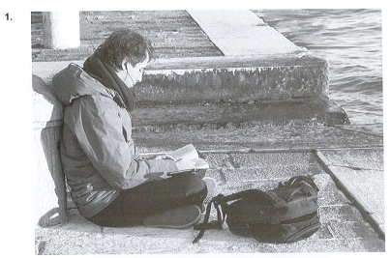 | 2.  A  B  C  D | 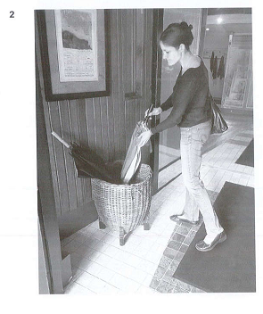
3.  A  B  C  D | 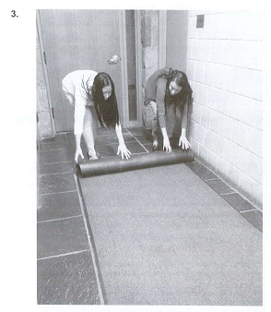 | 4.  A  B  C  D | 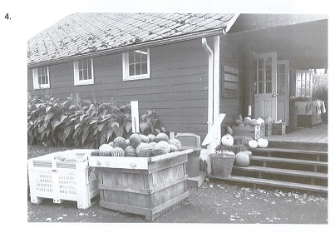
5.  A  B  C  D | 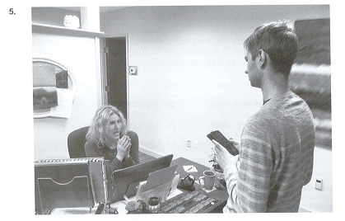 | 6.  A  B  C  D | 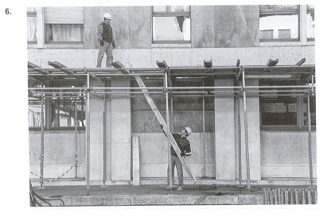

Part 2: Questions and Responses
Directions: you will hear a question or statement and three responses spoken in English. They will not be printed in your test book and will be spoken only one time. Select the best response to the question or statement and mark the letter (A), ( B), or (C) on your answer sheet.

Example
You will hear: where is the meeting room?
You will also hear: A. To meet the new director.
B. It’s the first room on the right.
C. Yes, at two o’clock.
The best response to the question “Where is the meeting room?” is choice (B), “It’s the first room on the right,” so (B) is the correct answer. You should mark answer (B) on your answer sheet.

7. Mark your answer on your answer sheet.  8. Mark your answer on your answer sheet.  9. Mark your answer on your answer sheet.  10. Mark your answer on your answer sheet.  11. Mark your answer on your answer sheet.  12. Mark your answer on your answer sheet.  13. Mark your answer on your answer sheet.  14. Mark your answer on your answer sheet.  15. Mark your answer on your answer sheet.  16. Mark your answer on your answer sheet.  17. Mark your answer on your answer sheet.  18. Mark your answer on your answer sheet.  19. Mark your answer on your answer sheet.. | 20. Mark your answer on your answer sheet.  21. Mark your answer on your answer sheet.  22. Mark your answer on your answer sheet.  23. Mark your answer on your answer sheet.  24. Mark your answer on your answer sheet.  25. Mark your answer on your answer sheet.  26. Mark your answer on your answer sheet.  27. Mark your answer on your answer sheet.  28. Mark your answer on your answer sheet.  29. Mark your answer on your answer sheet.  30. Mark your answer on your answer sheet.  31. Mark your answer on your answer sheet.
Part 3: Short Conversations-
Directions: you will hear some conversations between two people. You will be asked to answer three questions about what the speakers say in each conversation. Select the best response to each question and mark the letter (A), (B), or (C) on your answer sheet. The conversations will be spoken only one time and will not be printed in your test book.

32. Where does the woman work?  (A) At an electronic store  (B) At an newspaper publisher  (C) At a bank  (D) At a hotel  33. Why is the man calling?  (A) To update a mailing address  (B) To complain about a billing error  (C) To inquire about a job opening  (D) To request a price estimate  34. What does the woman say she will do next?  (A) Schedule an appointment  (B) Talk to a coworker  (C) Process a refund  (D) Send some samples  35. What are the speakers prepare for?  (A) A training session  (B) A marketing presentation  (C) An employee celebration  (D) A board meeting  36. What problem does the man mention?  (A) A computer is not working  (B) A staff member is unavailable  (C) A document is incorrect  (D) A door is locked  37. What does the woman ask the man to do?  (A). Create name tags  (B) Set up some equipment  (C) Clean a conference room  (D) Confirm a supply order  44. Who most likely are the women?  (A) Athletes  (B) Musicians  (C) Radio announcers  (D) Clothing manufacturers  45. What do the women want to hire the man to do?  (A) Design some merchandise  (B) Repair some equipment  (C) Plan some events  (D) Move some furniture  46. What does the man request from the women?  (A) A reimbursement  (B) An official certificate  (C) A contract signature  (D) A complete questionnaire  47. How did the woman learn about a company’s products?  (A) She saw an advertisement  (B) She heard about them from a neighbor  (C) She is a regular customer  (D) She lives near the store  48. What does the man mention about the product?  (A) It is inexpensive  (B) It is easy to install  (C) It decreases water use  (D) It is available in many colors  49. What does the woman ask the man to do?  (A) Email more information  (B) Provide a cost estimate  (C) Schedule a delivery  (D) Call back later  56. What project is the man working on?  (A) Updating a Web site  (B) Editing a catalog  (C) Organizing a company banquet  (D) Writing a magazine article  57. What does the woman suggest changing?  (A) A company logo  (B) A project deadline  (C) Some prices  (D) Some photographs  58. What does the man say he will do?  (A) Contact some colleagues  (B) Review an inventory report  (C) Borrow some equipment  (D) Check a company handbook  59. Where do the speakers most likely work?  (A) At department store  (B) At an accounting firm  (C) At a law firm  (D) At an advertising agency  60. Why does the man say “Marius Cosmetics was my first account here”?  (A) To show that he understands a problem  (B) To explain that he no longer works with a client  (C) To complain about a coworker’s mistake  (D) To request a promotion  61. What does the man suggest doing?  (A) Rejecting a proposal  (B) Getting help from a manager  (C) Preparing some samples  (D) Revising a budget  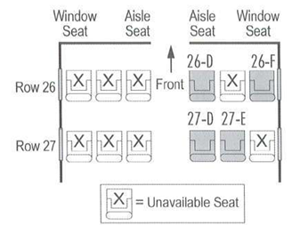  65. What is the purpose of the woman’s trip?  (A) To attend a conference  (B) To take a vacation  (C) To meet with some potential clients  (D) To assist with a branch opening  66. What does the woman agree to do?  (A) Give a presentation  (B) Pay an additional fee  (C) Travel on a different day  (D) Make a dinner reservation  67. Look at the graphic. Which seat does the woman request?  (A) 26D  (B) 26F  (C) 27D  (D) 27F | 38. Where does the man work?  (A) At a travel agency  (B) At a theater  (C) At a museum  (D) At a fitness center  39. What is the reason for the call?  (A) A payment is late  (B) An event has been canceled  (C) A reservation is incomplete  (D) An offer will expire  40. What does the man say he will e-mail to the woman?  (A) A brochure  (B) A survey  (C) A sales receipt  (D) A discount code  41. What are the speakers planning?  (A) A client visit  (B) A health fair  (C) A fund-raising dinner  (D) A company outing  42. What does the woman mean when she say, “We’ve done that for three years in a row”?  (A) She does not have much experience with a task  (B) She thinks an activity has been popular  (C) She does not want to repeat an activity  (D) She does not need directions to a location  43. What does the man say he is concerned about?  (A) A price of a class  (B) The distance to a venue  (C) Road closures  (D) Scheduling conflicts  50. Who most likely is the man?  (A) A librarian  (B) A teacher  (C) A news reporter  (D) A local politician  51. What does the woman like the best about the new library building?  (A) Its modern appearance  (B) Its convenient location  (C) Its operating hours  (D) Its large book collection  52. What benefit will library members have?  (A) Free parking  (B) Discounts on special classes  (C) Access to electronic books  (D) Tickets to local museums  53. Why did the man go to the store?  (A) To meet a friend  (B) To return a purchase  (C) To pick up an order  (D) To join a rewards program  54. What problem does the salesperson have?  (A) She forgot her computer password  (B) She needs to leave work early  (C) She lost her identification badge  (D) She is not familiar with a procedure  55. What does the manager ask the man for?  (A) A telephone number  (B) A receipt  (C) A credit card  (D) A shipping address  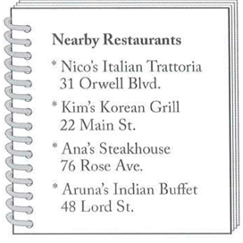  62. What field do the speakers most likely work in?  (A) Technology  (B) Journalism  (C) Medicine  (D) Agriculture  63. What will take place in the afternoon?  (A) An interview  (B) A workshop  (C) A job fair  (D) A trade show  64. Look at the graphic, where will the speakers probably have lunch?  (A) At Nico’s Italian Trattoria  (B) At Kim’s Korean Grill  (C) At Ana’s Steakhouse  (D) At Aruna’s Indian Buffet  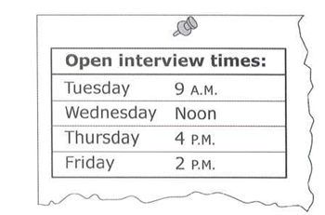  68. What kind of experience does the man say he has?  (A) Advertising  (B) Customer service  (C) Delivery  (D) Marketing  69. Look at the graphic. Which day will the man be interviewed?  (A) On Tuesday  (B) On Wednesday  (C) On Thursday  (D) On Friday  70. According to the woman, what should the man bring to the interview?  (A) A list of references  (B) A professional certificate  (C) A photo ID  (D) a printed application

Part 4: Short Talks
Listen and choose the best answer to each question.
Directions: You will hear some short talks given by a single speaker. You will be asked to answer three questions about what the speaker says in each short talk. Select the best response to each question and mark the letter (A), (B), (C) or (D) on your answer sheet. The talks will be spoken only one time and will not be printed in your test book.

71. Why are some colleagues visiting the company?  (A) To inspect a facility  (B) To celebrate an anniversary  (C) To make a presentation  (D) To participate in a training  72. What are the listeners asked to volunteer to do?  (A) Give a city tour  (B) Arrange transportation  (C) Prepare some documents  (D) Contact catering service  73. What are the volunteers asked to send in an e-mail?  (A) Their qualifications  (B) Their availability  (C) Contact information  (D) A list of supplies  74. Where does the announcement most likely take place?  (A) At a train station  (B) At a taxi stand  (C) At a ferry terminal  (D) At an airport  75. According to the speaker, what has been changed?  (A) A boarding time  (B) A refund policy  (C) A departure gate  (D) A trip rout  76. What does the speaker say the listeners must show?  (A) Proof of payment  (B) Photo identification  (C) A credit card  (D) An itinerary  83. What good news does the speaker share?  (A) A contract was renewed  (B) A deadline was extended  (C) A new employee was hired  (D) A larger building was purchased  84. What kind of business does the speaker work for?  (A) An automobile factory  (B) A landscape service  (C) A book printing company  (D) A dry cleaning service  85. What does the speaker mean when he says, “I’ve already called the manufacturer”?  (A) He expects sales to increase  (B) He has extra time to help  (C) He has reassigned a task  (D) He is addressing a complaint  86. What does the speaker’s company sell?  (A) Packaged foods  (B) Agricultural equipment  (C) Home electronics  (D) Travel insurance  87. According to the speaker, what will happen next Friday?  (A) A potential client will visit  (B) A language course will begin  (C) A computer system will be installed  (D) Some construction will be completed  88. What does the speaker ask the listener to do?  (A) Reserve a table  (B) Notify a supervisor  (C) Pick up a vehicle  (D) Hire an interpreter  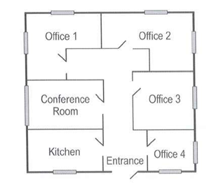  95. Which department does the speaker most likely work in?  (A) Customer service  (B) Product development  (C) Maintenance  (D) Shipping  96. Why does the speaker want to meet with the listener?  (A) To make an introduction  (B) To handle a complaint  (C) To discuss a project  (D) To sign a contract  97. Look at the graphic. Which is the speaker’s office?  (A) Office 1  (B) Office 2  (C) Office 3  (D) Office 4 | 77. What is the main topic of the report?  (A) Community activities  (B) Traffic updates  (C) Business tips  (D) Entertainment news  78. What does the speaker recommend that the listeners do?  (A) Fill out a survey  (B) Attend a town meeting  (C) Check a map  (D) Drive slowly  79. What does the speaker say will happen next week?  (A) A prize will be given  (B) A construction project will start  (C) A company office will open  (D) A government official will be interviewed  80. Where most likely are the listeners?  (A) On a bus  (B) On a boat  (C) At a museum  (D) At a library  81. According to the speaker, what will the listeners be able to see?  (A) Local markets  (B) Unusual wildlife  (C) Historic buildings  (D) Famous artwork  82. What does the speaker imply what he says “We’ll be coming back the opposite way on the return trip”?  (A) The listeners will be able to take pictures  (B) There was an error in a travel itinerary  (C) The listeners can use some lockers  (D) The listeners should buy souvenirs  89. Where most likely are the listeners?  (A) At a professional conference  (B) At a career fair  (C) At a board meeting  (D) At a community festival  90. What will Dr. Jimenez talk about?  (A) Workplace safety  (B) Corporate investments  (C) Productivity and time management  (D) Personality traits and success  91. According to the speaker, what should the listeners do by the end of the month?  (A) Register for an event  (B) Submit a time sheet  (C) Sign a card  (D) Read a publication  92. Where does the speaker work?  (A) At a national park  (B) At a science museum  (C) At a university  (D) At a public library  93. What does the speaker imply when he says, “the seating area is almost full”?  (A) More chairs are needed  (B) Some people cannot attend an event  (C) A fund-raising goal was reached  (D) A lecture is popular  94. What does the speaker ask the listeners to do?  (A) Raise their hands to ask questions  (B) Turn off their mobile phones  (C) Stay in a designated area  (D) Refer to a map  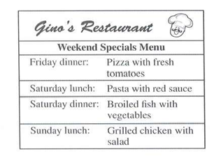  98. Who are the listeners?  (A) Cooks  (B) Managers  (C) Food distributors  (D) Safety inspectors  99. Look at the graphic. What menu item will need to be replaced?  (A) Pizza  (B) Pasta  (C) Broiled fish  (D) Grilled chicken  100. What does the speaker want the listeners to do by 4.00 PM today?  (A) Prepare for an inspection  (B) E-mail some suggestions  (C) Arrange a delivery  (D) Print a new menu

THE END OF LISTENING TEST NO.1

